Release Notes for Version 19.0.79
(Released on December 18, 2024)

306248 - Show an error/warning message when a conduit with cabling inside/connected is deleted.
This enhancement will notify users if they attempt to delete a Conduit that has any Cables located inside the Conduit itself or any of the individual Ducts, Sub-Ducts or Micro Ducts contained within.

307164 - Give users the ability to create a 2 X Splitter Diagram
The below information was copied from previous Release Notes that contain the details of new ‘Splitter Diagram’ functionality. This new enhancement, explained in the above ADO ticket 307162, allows for ‘two IN strands’ to now be shown in the diagram, instead of one.

DVL-5367 – Creation of new Splitter Diagram buttons to the fiber toolbar
DVL-5368 – Description of the left portion of the Splitter Diagrams
DVL-5369 – Description of the center portion of the Splitter Diagram
DVL-5370 – Description of the right portion of the Splitter Diagram

*All four of the above tickets are related directly to newly created functionality allowing users to create Splitter Diagrams. These diagrams show the input strand information as well as the output information on each port.

There are two new buttons that have been added to the Fiber toolbar, Create Spitter Diagram and View Splitter Diagram as shown in the image below:
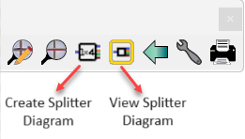

Users will first pick on the Create Splitter Diagram button and then on a Splitter found anywhere in the project. When the Splitter Diagram is complete, an automatic close message will open at the top left of the screen.

Once the diagram is created, a user can then select on the View Splitter Diagram button, followed by selecting a diagram out of the list or selecting directly on a Splitter symbol. Once the Splitter has been selected, the following diagram will appear.

These diagrams will now show one or ‘two IN strands’. The example below shows one IN strand.
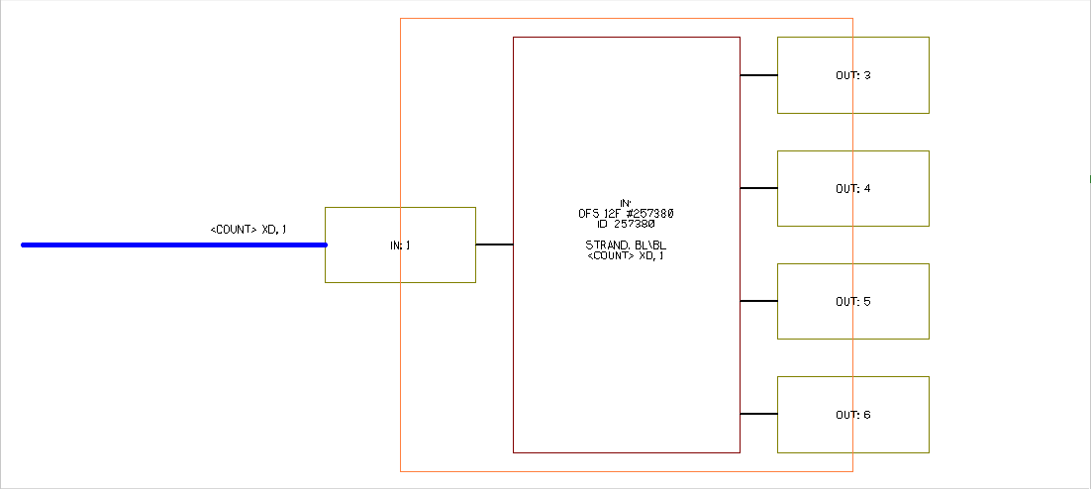

307209 - When Posting work order M4 automatically change the correct symbol for the layer
In previous versions of M4, when a user posted a Work Order and the symbols between the FPA and PPA layers were different, that symbol would not change correctly. This solution will now change this symbol correctly when a user posts a Work Order.

12/18/2024 EK

