Release Notes for Versions 19.0.78
(Released on October 18, 2024)

Desktop Jira Tickets

DVL-5454 - Give users the ability to minimize the icon section of the main M4 toolbar
This enhancement will now allow users to minimize the Icons section at the top of the main M4 project screen, leaving only the Active Map and Toolbar Tabs visible. As shown in the images below, right clicking on the top right, just under the X that is used to close the project, will allow you to select ‘Hide Toolbar’. Right clicking on the same spot, with the Icons already minimized, will give the option to ‘Show Toolbar’.
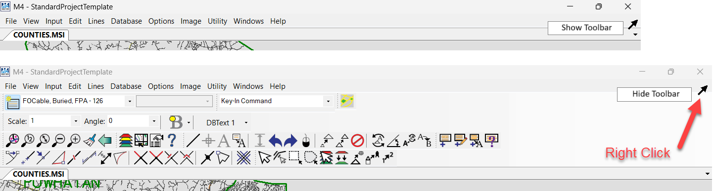

DVL-5465 - Change the word Details to the word Imagery when right clicking on a Template in NEM
This fix simply changes the word ‘Details’ to the word ‘Imagery’ when right clicking on a Template. It has been changed to ‘Imagery’ because it is used to attached images.

DVL-5481 - Cancel out of creating all staking sheets
In past versions, the ‘Create All Staking Sheets’ function could not be stopped once the button was depressed. This could result in the user waiting for quite some time until the process was complete. This enhancement will allow a user to stop the process if the button was incidentally pressed. Pressing ‘Esc’ on the keyboard will accomplish termination of that process.

DVL-5482 - Gila River requests ability to change the Highlight color for Highlight Pre-Post States
Highlighting Pre-Post States can now be shown in a color of the users choice. To make this change, a user should: Open the ‘Work Order’ toolbar select ‘Tools’ select ‘All Work Orders’ tab’ select ‘Configuration’ select ‘Posting States’ tab select ‘Pre-Post Highlight Color Settings’ tab. The colors can be changed here, as shown in the image below.
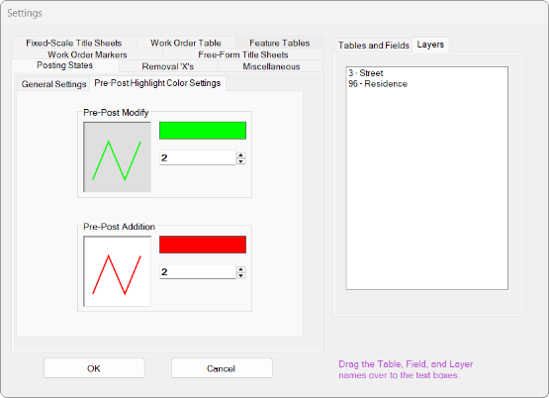
Desktop ADO Tickets (same as Jira tickets, different ticketing system only)

282497 - Would like for SELECT_FROM_SHAPE_ELEMENT to work using a selection set
This enhancement will maintain the current function of being able to pick by a singe boundary and will now allow a user to select all the boundaries on a certain layer using the select tool. After the selection is made, the user would be able to type in SELECT_FROM_SHAPE_ELEMENT ADD INSIDE in the Key-In Command box and press Enter. At that point all the elements inside the selected boundaries would become selected.

Console
DVL-5466 - Add Google Maps button to Console toolbar
Users will now have the option to use Google Maps when in Console. While there is no transparency slider as there is in Desktop, the ability to use the Google Maps feature is a great step to help users with accuracy.
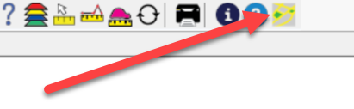

10/18/2024 EK

