Release Notes for Version 19.3.11
(Released on August 23, 2023)

Enhancements

DVL-5154 - 19.3 - Create a new button and dropdown selection for Input_Circles
An option has been added to the Input section of the Customize Toolbar Layout form to allow users to place a new ‘Input Circle’ icon on the standard M4 toolbar.
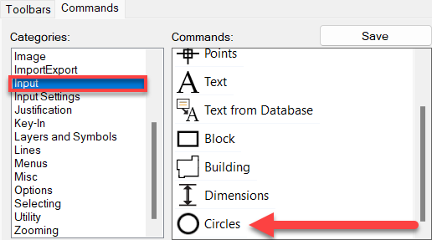

DVL-5160 - 19.3 – Remove Zoom To Me button from the standard toolbar
This change simply removes the ‘Zoom To Me’ button from the standard M4 toolbar.

DVL-5214 - 19.3 - Add an icon to the Customize Toolbar option for Precision Mouse
An option has been added to the Input section of the Customize Toolbar Layout form to allow users to place a new ‘Precision Mouse’ icon on the standard M4 toolbar.
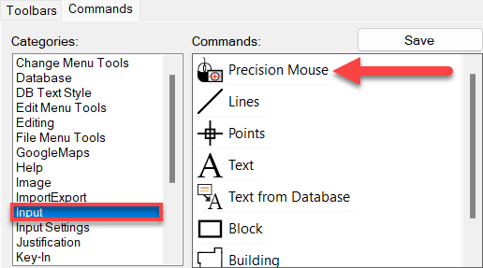

DVL-1983 - 19.3 - DELETEPROOF- Lets users have the ability to set deleteproof by table (Configured) instead of layer
This enhancement will allow users to not only use the ‘Deleteproof’ command on individual layers, but will also allow ‘Deleteproof’ on an entire table, such as FiberOpt. Below are examples of this newly created functionality:

LAYER_LOCK SpliceLocation,FiberOpt,FiberPassiveEquipment,CentralOffice,Bay LOCK
LAYER_LOCK SpliceLocation,FiberOpt,FiberPassiveEquipment,CentralOffice,Bay READONLY
LAYER_LOCK SpliceLocation,FiberOpt,FiberPassiveEquipment,CentralOffice,Bay DELETEPROOF
LAYER_LOCK SpliceLocation,FiberOpt,FiberPassiveEquipment,CentralOffice,Bay UNLOCK

DVL-5151 - 19.3 - Increase the tooltip duration in the Splice Diagram Interactive Setup form
This enhancement will increase the amount of time that the tooltip remains visible in the ‘Splice Diagram Interactive Setup’ form when hovering over individual fibers.

DVL-5253 – 19.3 – Some path options should not be available in the Select Route form when running a trace on a specific strand
This enhancement help M4 when tracing through splitter locations, to not offer path options that are not
correct

DVL-5158 - 19.3 – Allow users to hide selected layers in the Active Layer List dropdown
Users are now able to hide layers from the Active Layer List on the standard M4 toolbar. To hide a layer, simply go into M4 Administrator, select the layer you wish to hide out of the Layer List, select the Rules 2 tab and check the box ‘Hide/Hidden in Layer List Dropdown’.
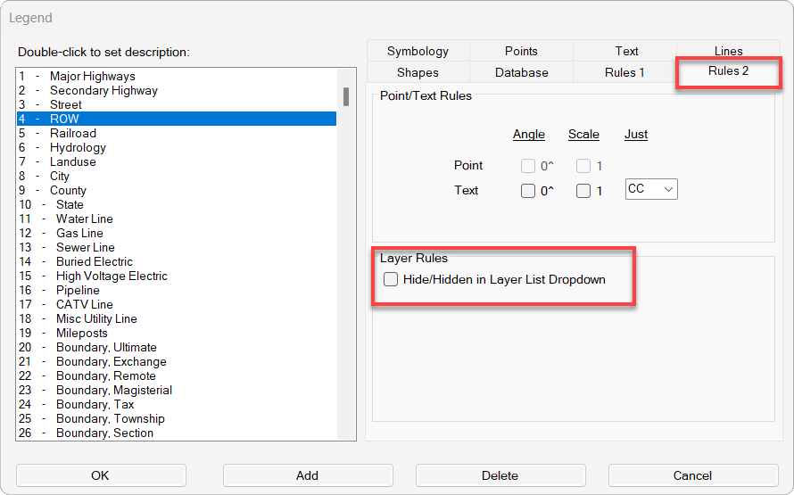

DVL-990 - 19.3 - Add configuration for dBloss in feet, currently works in Kilofeet
The dBLoss being used with Fibers may now be calculated in Feet or in Kilofeet. To change this setting, select ‘Utilities’ on the Fiber toolbar, select ‘Fiber Configuration’, select the ‘Splices tab’ at the top of the Fiber Configuration form and then toggle on the prefered setting at the bottom of the form in the ‘dBLoss Input Unit’ section.
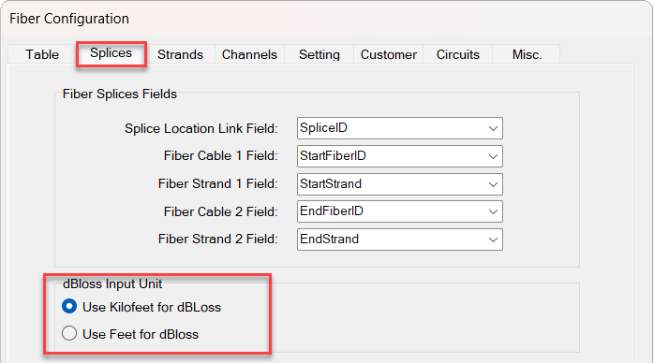

DVL-5202 - 19.3 - Add the ability to Cut Strands by Strand Range
Cutting Strands functionality was added in a previous version of 19.3, and this enhancement will now allow users to cut these strands by strand range, as it works when creating a fiber splice. The new button for this can be found at the bottom of the ‘Cut Strands’ form.
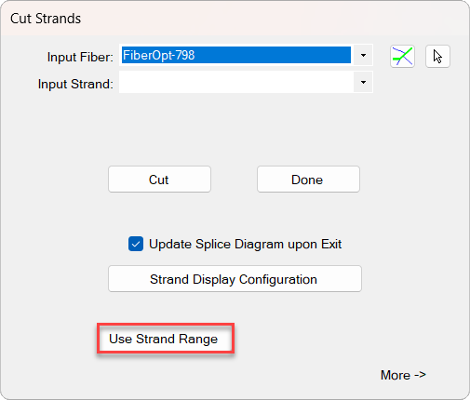

DVL-5218 - 19.3 - Part Number field in Template Builder should accept Null values
Users will now be able to enter a ‘0’ in the ‘Null’ field of Equipment Template Builder.
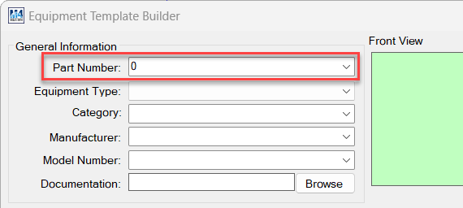

DVL-5175 - Integrate software analytics and monitoring tools into the M4 application using Application Insights
To help us better understand how M4 is used and to ensure that our development team spends their time as wisely as possible, we have added product usage tracking to the latest version of 19.0.74 and 19.3.11. The information will help us answer questions such as, how often the software is run, and which modules are used most frequently.

The information is limited to the use of M4 and is completely anonymous. VertiGIS will never collect information of a personal nature, such as your name or any other computer activity. If a user or an organization would prefer not to provide this anonymous data, they can “opt-out” by adjusting the appropriate settings (found in the Misc. tab inside the ‘Project Setup’ section of M4 Administrator as shown in the image below).
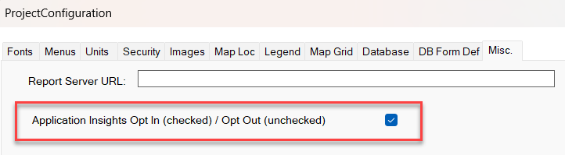

Bug Fixes:

19.3 - The Edit Text form will not allow M4 to regain focus
19.3 - Should be able to create a block by using specific dimensions
Error with SPREADSHEET_FROM_SELECTION_SET Key-In Command
2019.3 - Scaling issue with Staking sheets
19.3 - Message when placing a Structure using the Structure Management Tool contains 'Mapcom'
19.3 - Selecting on Zooming option in Customize Toolbar Layout form produces error
19.3 - Selecting on Menus option in Customize Toolbar Layout form produces error
Message needs to appear when Google Key is empty
19.3.8 Map Rescale command throwing error message
19.3 - Add a warning message when someone clicks on Delete on the Image Pick and Show form
19.3 - Allow users to create default Key-In commands that will populate the Key-In command upon opening M4
19.3 - App Insights change of Total Usage
FiberCount Field Not Creating New Lines After Line Break
19.3 - Need AppInsights Opt In / Opt Out changes to take place as soon as the box is checked or unchecked
19.3 - Function Keys are not saving values entered
19.3 - Hunter issue and error at splitter location
Auto-Registration Tool Not Recognizing M4 In 19.3.10
19.3 - Height in Equipment Template Builder is reducing value by 1 after saving
2019.3 - Multiple Manufacturers in Shelf Produces Error
19.3 NEM- Image not Displaying when using part number
Editing Work Order Prompts Warning that WO Already Exists
19.3 - Installer is making it impossible to open Work Order on some machines

Release Notes for Version 19.3.12 – 19.3.13
(Released on September 6, 2023)

Enhancements

DVL-771 - 19.3 - The Edit Text form will not allow M4 to regain focus
This enhancement allows the user to pan around in M4, even though the ‘Text Edit’ form is in the forefront.
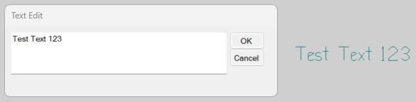

DVL-796 - 19.3 - Should be able to create a block by using specific dimensions
This new functionality allows users to create Blocks using a specific width and a specific height.

The Key-In Command for this functionality is: INPUT_BLOCK_BY_DIMENSIONS

Once the command is entered into the Key-In, and Enter is selected, the following form will open: (the dimensions should be entered as width, a space, and the height).
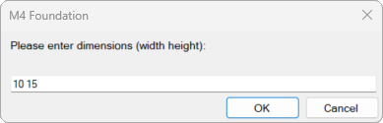

After the user selects on the OK button, the specified block will generate on the end of the cursor, ready to be placed into M4.

As an additional note, these dimensions WILL accept decimals.

DVL - 19.3 - The 'Wiki' link in the Help dropdown is no longer directing to the correct Zendesk page
This enhancement will change the word ‘Wiki’ in the Help dropdown menu on the standard M4 toolbar to ‘Support’. For this to work, a user must right click in the empty grey portion of the standard toolbar. When the menu drops down, select ‘Customize…’ and then ‘Reset to Default’ on the bottom right of the ‘Customize’ form.
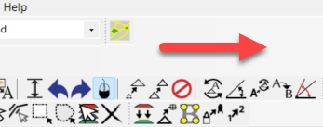

DVL-5237 - 19.3 - Message when placing a Structure using the Structure Management Tool contains 'Mapcom'
This change simply removes the name ‘Mapcom’ from this instance of the Structure Management Tool, replacing it with ‘VertiGIS’.
DVL-5258 - Message needs to appear when Google Key is empty
All clients moving to versions 19 and 19.3 will now be required to attain a unique API Key to use Google Maps in their M4 project. When upgraded, they will need to have this code updated one time. There are individuals in support and in several other departments that are already aware of how this new process will work and who have the ability to generate these keys. The message they will receive if the API Key entry is blank, looks like the following:
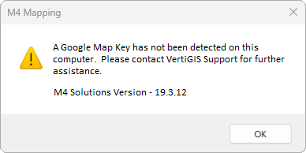

The actual entry block for this new, unique API Key, can be found in M4 Administrator, inside the Misc. tab as shown in the image below:
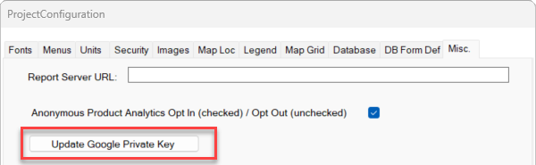

Once a user selects the ‘Update Google Private Key’ button, an M4 Administrator form will open allowing for the unique entry to be entered.
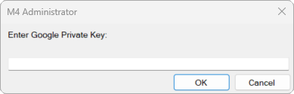

DVL-5267 - 19.3 - Add a warning message when someone clicks on Delete on the Image Pick and Show form
The purpose of this message, is to let the user know there is an image attached to an element prior to the deletion of that element. This will give them the opportunity to view, or copy, the image before the deletion is complete.
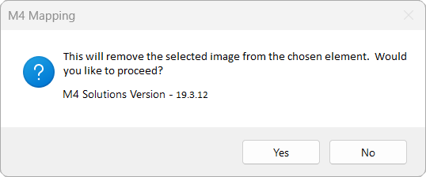
DVL-5273 - 19.3 - Allow users to create default Key-In commands that will populate the Key-In command upon opening M4
This new enhancement allows users to set up a list of Key-In Commands that will auto populate in the Key-In dropdown every time they open M4. To set up these values, the user will select on the ‘Settings’ icon on the standard toolbar and then select on the new ‘Toolbars’ tab. (This is shown in the image below.)
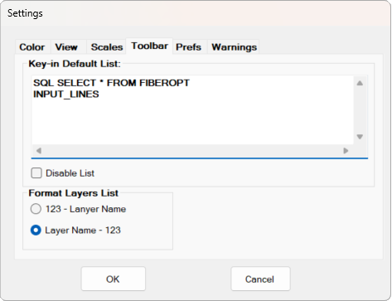

Other notes about this enhancement include:
-There are 19 entries allowed in the ‘Key-In Default List’.
-This Key-In command list in the ‘Toolbar’ tab will be perfectly mirrored in the Key-In Command dropdown on the standard toolbar.
-Users will have the option to disable the list by placing a check in the ‘Disable List’ checkbox found below the Key-In entries.
-The ‘Format Layers List’ section has been moved from the ‘Prefs’ tab to the new ‘Toolbar’ tab. It can be found below the ‘Disable List’ checkbox, which can be seen in the image above.

DVL-5275 - 19.3 - App Insights change of Total Usage
This enhancement will only be seen by those individuals on the VertiGIS team that are using the Application Insights software to help evaluate M4 usage analytics.

The change to the Application Insights Analytics tracking information is based on a duration string. The old duration was a very long string of information as shown in the image below:

The duration tracking string will now have a total of minutes, making it a much easier to consume and evaluate:

DVL-5312 - 19.3 - Give users the ability to suspend Posting State warnings
This enhancement will allow users to suspend warnings that appear when the active layer and Posting State do not align with one another when attempting to Commit a database record. This change can be found in the Work Order Configuration.

***** While this is now an option for users, it is not recommended unless the workflow is impacted in a negative manner. This could impact data integrity and should be considered carefully by all users.
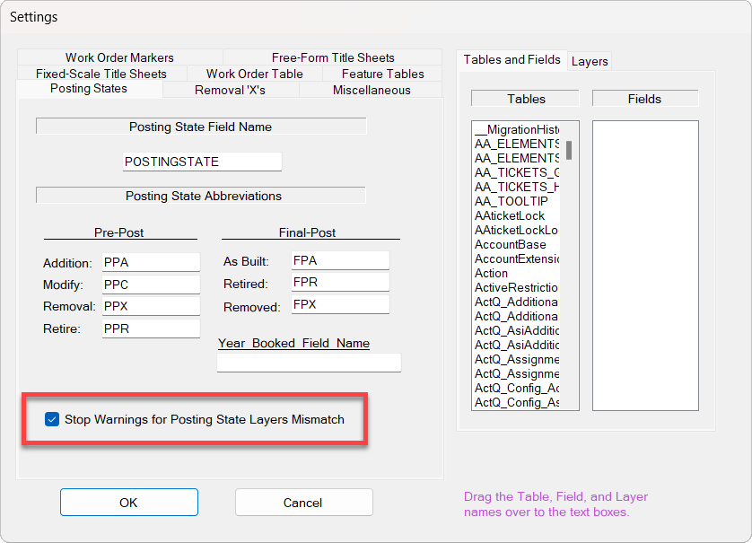

Bug Fixes:

-Error with SPREADSHEET_FROM_SELECTION_SET Key-In Command
-2019.3 - Multiple Manufacturers in Shelf Produces Error
-19.3 - Height in Equipment Template Builder is reducing value by 1 after saving
-2019.3 - Scaling issue with Staking sheets
-19.3 - Selecting on Menus option in Customize Toolbar Layout form produces error
-19.3 - Selecting on Zooming option in Customize Toolbar Layout form produces error
-Auto-Registration Tool Not Recognizing M4 In 19.3.10
-19.3 NEM- Image not Displaying when using part number
-19.3.8 Map Rescale command throwing error message
-FiberCount Field Not Creating New Lines After Line Break
-19.3 - Need AppInsights Opt In / Opt Out changes to take place as soon as the box is checked or unchecked
-19.3 - SHOW_SQL key-in commands are throwing errors
Editing Work Order Prompts Warning that WO Already Exists
-19.3 - Hunter issue and error at splitter location
-19.3 - Installer is making it impossible to open Work Order on some machines
-19.3 - Function Keys are not saving values entered
-2019.3 - Plot Print function is slow

Release Notes for Versions 19.3.14 – 24.4
(Released on May 15, 2024)

Enhancements

DVL-5350 – Expand Edit Passive Paths diagram in Fiber to the Home tools
Using the arrow at the bottom right of the form, this enhancement allows users to expand the Edit Passive Paths ports to allow for better views of the input and output information related to a splitter.
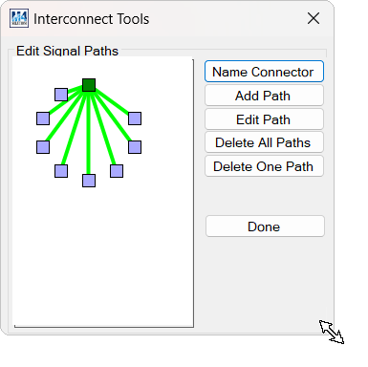
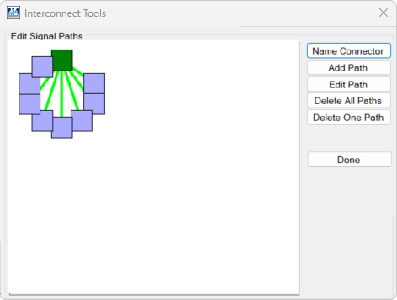

DVL-5367 – Creation of new Splitter Diagram buttons to the fiber toolbar
DVL-5368 – Description of the left portion of the Splitter Diagrams
DVL-5369 – Description of the center portion of the Splitter Diagram
DVL-5370 – Description of the right portion of the Splitter Diagram
All four of the above tickets are related directly to newly created functionality allowing users to create Splitter Diagrams. These diagrams show the input strand information as well as the output information on each port.

There are two new buttons that have been added to the Fiber toolbar, Create Spitter Diagram and View Splitter Diagram as shown in the image below:
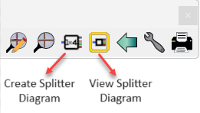

Users will first pick on the Create Splitter Diagram button and then on a Splitter found anywhere in the project. When the Splitter Diagram is complete, an automatic close message will open at the top left of the screen.

Once the diagram is created, a user can then select on the View Splitter Diagram button, followed by selecting a diagram out of the list or selecting directly on a Splitter symbol. Once the Splitter has been selected, the following diagram will appear.
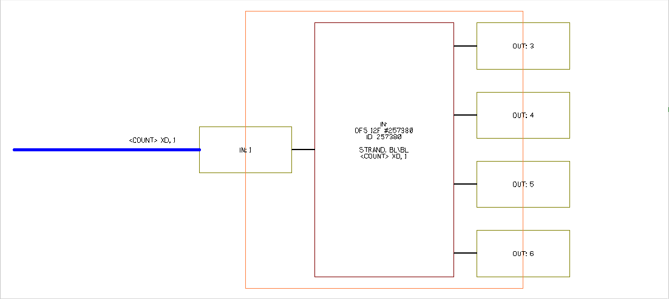

DVL-5394 – INTERFACE DESIGN - Give users the ability to customize the right click shortcut menu in
the project space
DVL-5398 – INTEGRATION WITH FOUNDATION - Give users the ability to customize the right click shortcut menu in the project space
DVL-5399 – DB DESIGN - Give users the ability to customize the right click shortcut menu in the project space
All three of the above tickets are related directly to newly created functionality allowing users to customize the right-click menu that appears in the project space.

When right clicking on the main project screen, the following menu appears on the cursor:
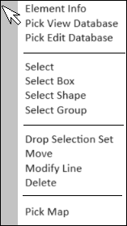
This enhancement will allow users to customize the above menu by selecting the ‘Customize Toolbar Layout’ option in the ‘Options’ dropdown menu on the standard M4 toolbar.

Once the ‘Customize’ form has opened, notice there is a new tab to the right called ‘Custom Shortcut Menu’. Accessing this tab will allow the user to add or remove any toolbar icons and line separators into the personal right-click menu that is used in the M4 Project workspace. The tab and new ‘Customize’ form can be seen in the images below:
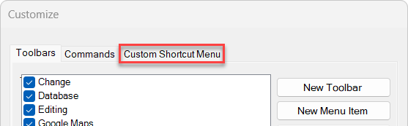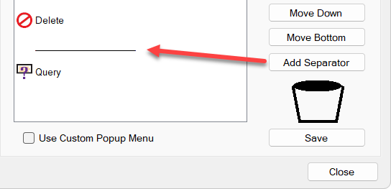

DVL-5411 – Add a progress bar to opening the Circuit Transfer form
When a user would select on the Open Circuit Transfer Form button on the Circuit toolbar (to the left), it was difficult to tell that a process.

Bug Fixes:

-Ritter Measure Geographically issue with fixed scale work prints
-Opening a database and then selecting Find on Map in Query results produces an error
-Need to remove the message allowing user to change Templates for Passive Paths in Template Builder
-When Adding a New Circuit, the tooltip does not update until leaving the strand and coming back
-Define Virtual Path form is unlike all of the other forms in M4
-Error is produced by left clicking in Remove Restrictions box
-Unable to save a Font after rotating it in Font Designer
-MAP_MOVE is allowing the move, but is not snapping using Ctrl+Left click
-MAP_ROTATE_SCALE is allowing the move, but not rescaling the text
-After scaling text - after MAP_ROTATE_SCALE text - is shifting from original handle
-Print Preview not responding to paper orientation
-'Fiber to OSP equipment' popup window issue
-DB DESIGN - Do not give CONSOLE users the ability to customize the right click shortcut menu in the project space
-Change the word 'Splice' to 'Splitter' on the View Splitter Diagram form
-24 - Need to give the ability to bypass Circuit function created in 2018
-24 - Delete Circuit Form Issues
-Error with Load Circuits in EDIT/DELETE forms

If you have any questions about this document or the changes that have been made, please email erin.kessinger@vertigis.com.

